|  |  |
| --- | --- |
| **Network Infrastructure**  Diploma in CSF / IT  Year 2 (2020/21) Semester 3 | Week 04 |
| Practical |
| Dynamic Routing - RIP | |

**Objective**

At the end of this practical, student should be able to set up dynamic routing (Routing Information Protocol) on routers.

**Resources**

Windows machines, switches, routers, UTP cables

**Activities**

The class will be divided into teams of 3 to 4 students. Each team will break into two groups of 2 students.

* Group 1 will work on network segment 1 and Group 2 on Network segment 2.
* After the two groups have set up their own respective segment, the team will connect the two segments to form a larger routed network.

As you are setting up and configuring the network, always attempt to solve any problem encountered using the following approach:

* Start with the Layer 1 investigation:
  + Check that the UTP cables used to connect the switches and routers are correctly connected.
  + Investigate the status LED lights on all devices – routers, switches and PCs.
  + Check that the switches and routers are powered on.
* After verifying that Layer 1 is functioning, determine whether the problems reside in Layer 2:
  + Check routers’ interfaces are enabled by “no shutdown” command.
  + Ensure that the connected ports on the switch are on the same VLAN (default: VLAN1).
* After verifying Layer 2, troubleshoot Layer 3 and above problems using tools such as ping and tracert commands to isolate and determine the problems.

**Activity 1: To set up a network segment.**

**Step 1:** Study the Network diagrams on pages 2 and 3 and set up the physical connection accordingly.

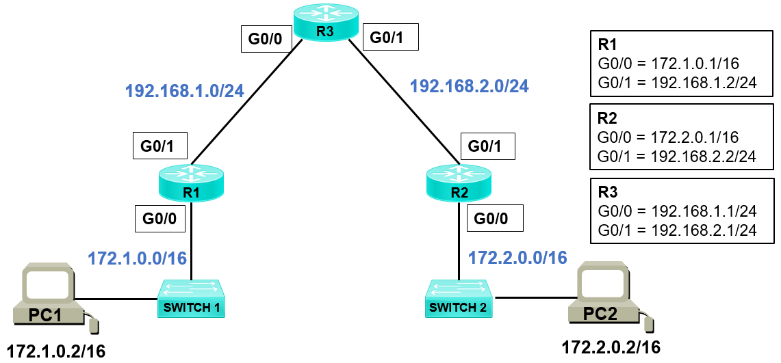

**Figure 1: Network Segment 1**

|  |  |  |  |  |  |
| --- | --- | --- | --- | --- | --- |
| **Device** | **Hostname** | **Interface** | **IP Address** | **Subnet Mask** | **Default Gateway** |
| R1 | Branch1 | GE G0/0  GE G0/1 | 172.1.0.1  192.168.1.2 | 255.255.0.0  255.255.255.0 |  |
| R2 | Branch2 | GE G0/0  GE G0/1 | 172.2.0.1  192.168.2.2 | 255.255.0.0  255.255.255.0 |  |
| R3 | HQ1 | GE G0/0  GE G0/1 | 192.168.1.1  192.168.2.1 | 255.255.255.0  255.255.255.0 |  |
| PC1 | Host1 | NIC | 172.1.0.2 | 255.255.0.0 | 172.1.0.1 |
| PC2 | Host2 | NIC | 172.2.0.2 | 255.255.0.0 | 172.2.0.1 |

**Table 1: Device Configuration Summary**

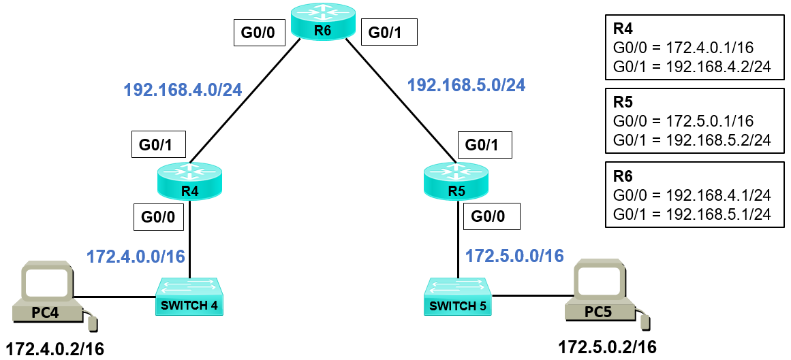

**Figure 2: Network Segment 2**

|  |  |  |  |  |  |
| --- | --- | --- | --- | --- | --- |
| **Device** | **Hostname** | **Interface** | **IP Address** | **Subnet Mask** | **Default Gateway** |
| R4 | Branch4 | GE G0/0  GE G0/1 | 172.4.0.1  192.168.4.2 | 255.255.0.0  255.255.255.0 |  |
| R5 | Branch5 | GE G0/0  GE G0/1 | 172.5.0.1  192.168.5.2 | 255.255.0.0  255.255.255.0 |  |
| R6 | HQ2 | GE G0/0  GE G0/1 | 192.168.4.1  192.168.5.1 | 255.255.255.0  255.255.255.0 |  |
| PC4 | Host4 | NIC | 172.4.0.2 | 255.255.0.0 | 172.4.0.1 |
| PC5 | Host5 | NIC | 172.5.0.2 | 255.255.0.0 | 172.5.0.1 |

**Table 2: Device Configuration Summary**

**Step 2: Configure GigabitEthernet**

Based on the network topology given in Figure 1 and Figure 2 and the table of configuration information in Table 1 and Table 2, configure the interface parameters of the CISCO routers.

An example of a script is given below for your reference:

*R1#configure terminal (conf t – short form)*

*R1(config) #interface GigabitEthernet 0/0 (int g0/0 or int G0/0 – short form)*

*R1(config-if) #ip address 172.1.0.1 255.255.0.0*

*R1(config-if) #no shutdown (no shut – short form)*

**Ensure the correct IP parameters are used, no shutdown is issued to bring up the interfaces.**

**Step 3: Enable Routing using RIP routing protocol.**

An example of a script is given below for your reference:

*R1(config) #router rip*

*R1(config-router) #version 2 (default is version 1)*

*R1(config-router) #network 172.1.0.0*

*R1(config-router) #network 192.168.1.0*

**Ensure the correct network statement is used.**

(Please note that RIP version 1 and RIP version 2 are not compatible)

**Step 4: Configure IP parameters for hosts.**

Set the appropriate IP address, subnet mask and default gateway for each PC (PC1, PC2, PC4 and PC5).

**Activity 2: Testing**

From routers, confirm the interfaces IP settings (use **show run** command) and routing table (use **show ip route** command). Check that the interface ports are up and line protocols are up and working.

From PC1/PC4, confirm the IP setting, and progressively test the reachability from PC1/PC4 via intermediate routers to PC2/PC5 on the distant network using **ping** and **tracert** commands.

Report your findings:

|  |
| --- |
| The RIP works, and the routers are able to announce and discover each other’s subnets. It takes 4 hops for the data packet to be routed from PC1/PC4 to PC2/PC5. |

**Activity 3: Connecting up Network Segment 1 and 2 and Testing**

Create a larger routed network:

* + - Start a new Packer Tracer work space, copy and paste Network Segment 1 and Network Segment 2 created by the 2 groups
    - Connect router R3 on Segment 1 to router R6 on Segment 2 using a serial DCE connection (WAN link)

Configure the serial interfaces on R3 and R6.

Perform reachability test from PC1 on Segment 1 to PC5 on Segment 2 using Tracert command.

Report your findings:

|  |
| --- |
| If 1 router use RIP V2, all must use V2, if use V1 for 1 of the routers, the network will break.  We can use RIP for both copper straight-through cable and serial cable. |